

Name : Wong King Poh

Login ID :R03412914@oasis-portal.my

Course title : Executive Diploma in Culinary Arts & Hospitality Management

Subject Code : CA03 International Cuisine

Submitted date: **07/September/ 2017**

**Table of Contents**

|  |  |  |
| --- | --- | --- |
| **No** | **Details** | **Page** |
| 1 | Executive Summary | 2 |
| 2 | Introduction | 3-5 |
| 3 | Assignment Question |  |
|  | Part 1 | 6-18 |
| 4 | Conclusion | 19 |
| 5 | References | 20 |

**Executive Summary**

In this assignment, we will learn about the purpose of this unit that is to be able to understand International Cuisine within Culinary Arts and Hospitality Management.

We will need to choose one dish from each cuisine. The cuisine are Chinese, Western and Indian Cuisine. From each cuisine we will need to recreate or alter the original recipe in to our own recipe.

By doing this exercise, I learn that each cuisine are different from each other, for example Chinese cuisine do not use curry powder as much as indian cuisine. For indian cuisine they have the famaous roti canai, and for western food varies from different countries like hamburger from USA and pasta from Italy.

**Introduction**

International cuisine means food that come from different countries. For example as Malaysian the international cuisine are as below

**From Japan**

* Sushi
* Wasabi
* Tempura
* Udon
* Soba
* Ramen Yakitori
* Sashimi
* Tonkatsu
* Okonomiyaki
* Pickles
* Miso

**From Korea**

* Legumes
* Kimchi
* Bibimbap
* Bulgogi
* Japchae
* Hoeddeok
* Ddukbokkie
* Seolleongtang
* Soondubu Jiggae
* Samgyeopsal
* Haemul Pajeon
* Hobakjuk
* Naengmyeon
* Soondae
* Samgyetang

**From Indian**

* Idli
* Nethili Varuval
* Kati Roll
* Rajma
* Pani Puri
* Tandoori Chicken
* Dosa
* Dhokla
* Rumali Roti
* Kulfi
* Pakora
* Vada

**From Italy**

* Bigoli
* Ribollita
* Risi e bisi
* Tortellini en Brodo
* Canederli
* Osso buco alla Milanese
* Cacciucco
* Focaccia di recco
* Bottarga
* Torrone

**From Chinese**

* Peking duck
* Beef Chow Fun
* Guilinggao
* Yong Zhou Fried Rice
* Buddha Jumps Over The Wall
* Hainanese Chicken Rice
* Chong Qing Spicy Deep Fried Chicken
* Kung Pao Chicken
* Mapo Tofu
* Red Stewed Duck
* Kung Pao Chicken
* Soy Egg
* Tea Egg
* Zong Zi
* Moon Cake
* Shao Bing

**From French**

* **Soupe à l'oignon**
* **Coq au vin**
* **Cassoulet**
* **Beef bourguignon**
* **Chocolate soufflé**
* **Flamiche**
* **Confit de canard**
* **Nicoise salad**
* **Ratatouille**
* **Tarte tatin**

**From American**

* Hamburger
* Taco
* Burrito
* Chilli con carne
* Fish and chips
* Buffalo wing

**Assignment Questions**

You should create your own dish from each international cuisine listed.

Required:

Choose one dish for each cuisine:

1. Chinese cuisine
2. Indian Cuisine
3. Western Cuisine
4. Chinese Cuisine

**Original Yang Zhou Fried Rice**

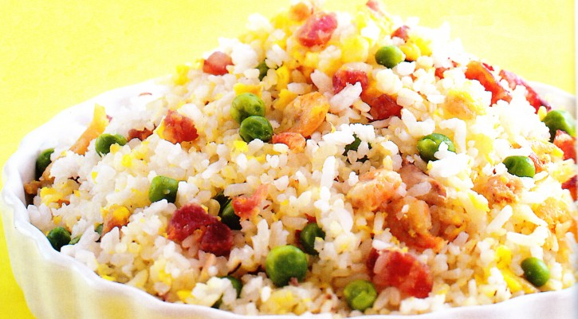

**Ingredients:**

* 2 tbsp vegetable oil
* 2 eggs, beaten
* 1 tbsp garlic, chopped
* 3 tbsp green onion, chopped
* 1 Chinese sausage, chopped finely
* 1 tbsp dried shrimps, chopped finely
* 5 cups rice
* 1/2 cup frozen green peas
* 2 tbsp soy sauce
* 5 pcs shrimp, peeled and chopped
* salt and pepper to taste

**Procedures:**

1. In a hot wok, place oil and cook egg and set aside.
2. Using the same pan, saute onion and garlic until fragrant is extracted but do not overcook.
3. Add the Chinese sausage, peeled shrimp and dried shrimps.
4. Follow with the rice, green peas and the cooked egg.
5. Season with soy sauce, salt and pepper.
6. Serve hot.

**Own recipe**

**Yang Zhou Fried Rice**

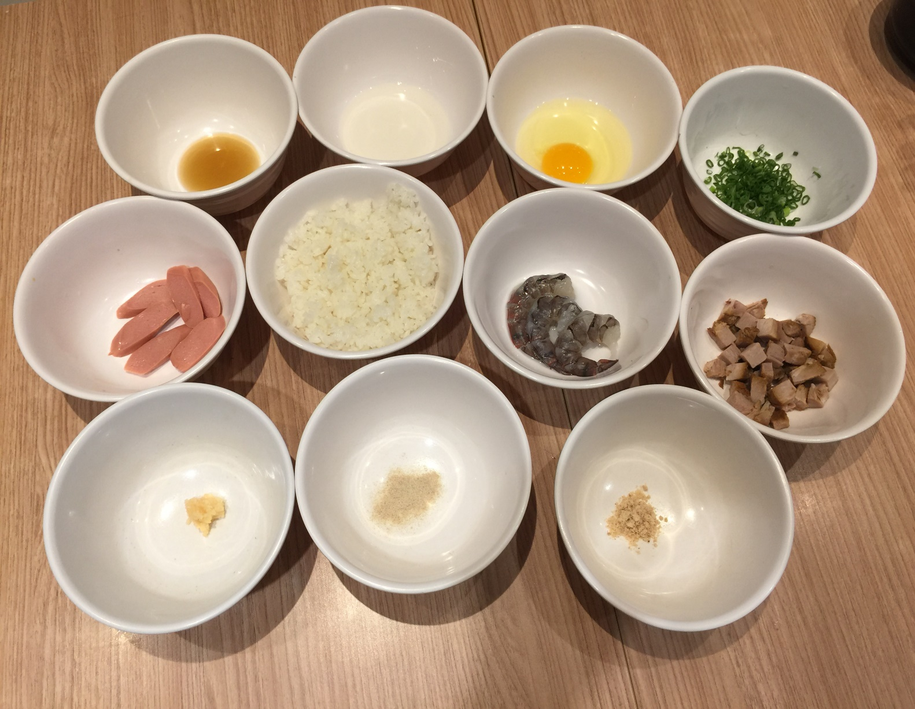

**Ingredients For Yang Zhou Fried Rice**

* 1 cup rice
* 1 pc sausage
* 3 prawn
* 100gm char siew
* 1 nos egg
* A bit spring onion
* ½ tbsp chopped garlic
* 3 tbsp cooking oil
* ½ tbsp chicken powder
* ½ tbsp soy sauce
* ¼ tbsp pepper

**Preparation For Yong Zhou Fried Rice**

1. Wash the rice. Add 1cup of water and cook in the rice cooker one day before.
2. Once cooked, use a chopstick to loosen the rice and refrigerate until the next day.
3. Soak the sausage in hot water for 10 mins .
4. Remove the shells from the prawn and remove the waste from the back of the prawn.
5. Wash prawns
6. Cut the char siew into small cubes.
7. Beat the eggs in a bowl and add a pinch of salt.
8. Wash the spring onion and cut into small pieces.
9. Loosen the day-old rice using a chopstick.

**Procedures:**

1. Make wok hot , put inside oil and cook egg then put aside
2. Saute garlic until fragrant is extracted
3. Put the sausage and prawn
4. Then with the rice and cooked the egg together
5. Put the char siew
6. Following with the chicken powder, soy sauce and pepper
7. Last put the spring onion and finish

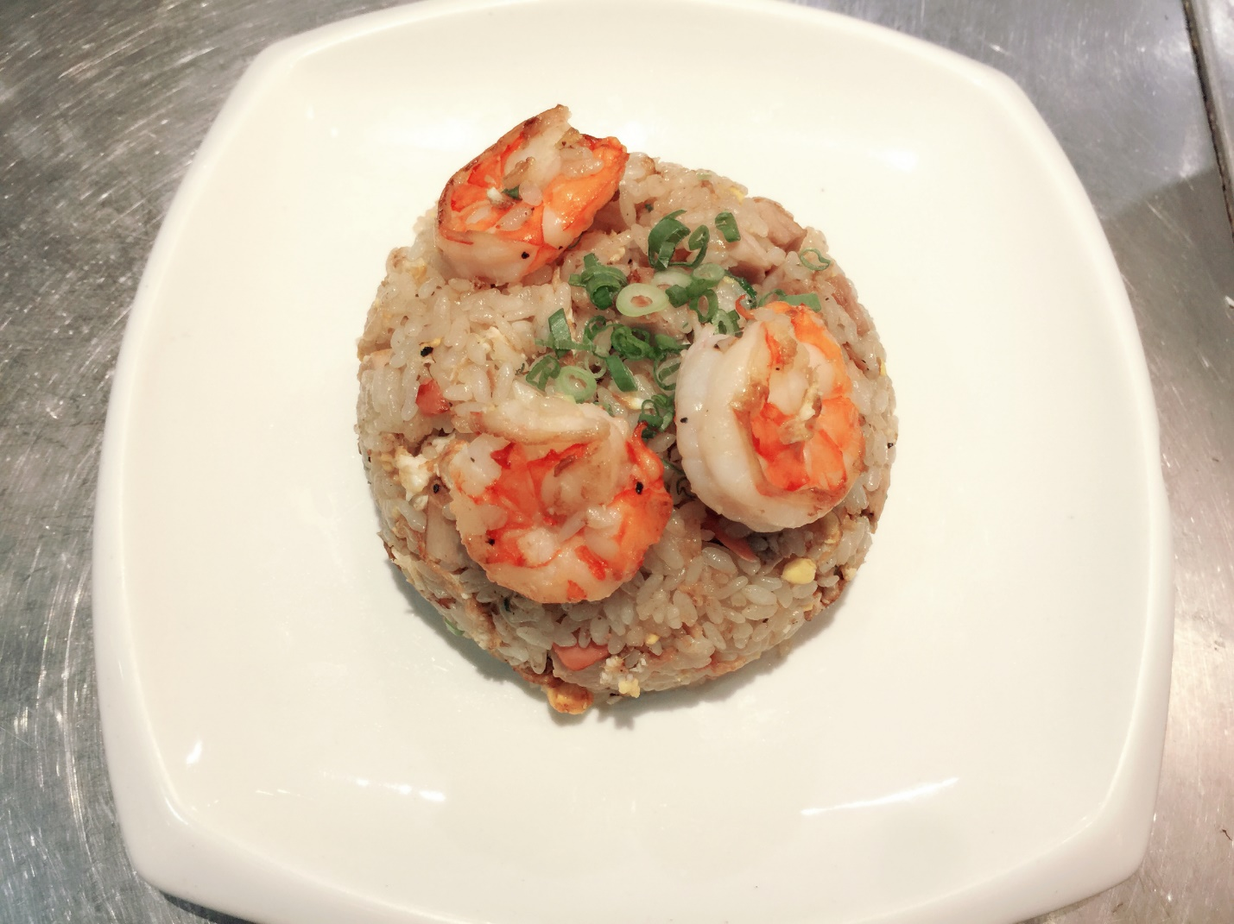

1. Indian cuisine

# **Original Chapatis**

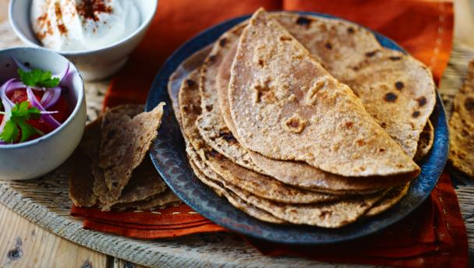

## **Ingredients**

* 450g/1 lb chapati flour or wholemeal [plain flour](http://www.bbc.co.uk/food/plain_flour)
* 1 tsp salt
* 250ml/9 fl oz cold water
* [butter](http://www.bbc.co.uk/food/butter) for spreading, optional

**Method**

1. Set aside 200g/7 oz of the flour and reserve for shaping the chapatis.
2. Place the remaining flour and salt in a deep bowl. Fill another bowl with the cold water.
3. Add the water to the bowl of flour, a little at a time, kneading as you go, until you have a soft, elastic dough. The longer you knead the dough the softer the chapattis will be.
4. Sprinkle a little of the reserved flour onto a flat surface or board. Divide the dough into eight and shape each piece into a ball. Flatten the balls slightly, then place one onto the floured board. Roll it out into a flat disc approximately 15cm (6 inches) in diameter, flouring the board when necessary.
5. Heat a griddle or a shallow frying pan. Lay the chapatti on the griddle or pan and cook for about 20-30 seconds or until the surface is bubbling.
6. Turn it over with tongs and cook the other side for 10-15 seconds. As soon as brown spots appear on the underside, the chapatti is done.
7. Repeat with the other seven balls, using the remaining flour to roll them out. Stack them up as they are cooked, placing a sheet of kitchen towel between each one to absorb any moisture.
8. Spread butter over one side, if you like.

**Own recipe**

**Chapatis**

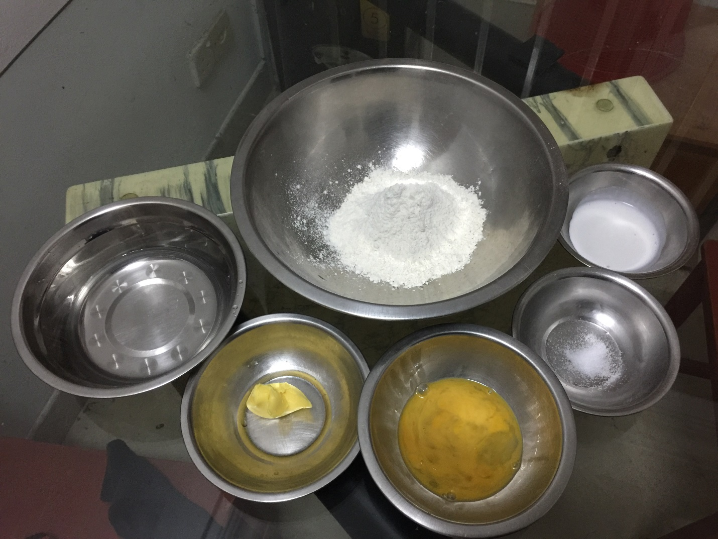

## **Ingredients For Chapatis**

* 300gm [plain flour](http://www.bbc.co.uk/food/plain_flour)
* 1 pich salt
* 20gm milk
* 1 nos egg
* 150gm water
* 20gm [butter](http://www.bbc.co.uk/food/butter)

**Preparation For Chapati**

1. Pour the flour, egg and salt into a large bowl.
2. Slowly pour water and cream into the flour, moving your other hand through the flour in circular motions.
3. Knead the dough until soft and pliant.
4. Rub the surface of the dough with melted butter to keep it from drying out.
5. Use a damp cloth and allow to rest.
6. Divide the dough and to form a ball, and then flatten with your palm. Then roll until it's a circle.

**Procedures:**

1. Heat a griddle . Lay the chapatti on the griddle and cook until the surface is bubbling.
2. Turn it over with tongs and cook the other side, until as brown spots appear on the underside, the chapatti is done.

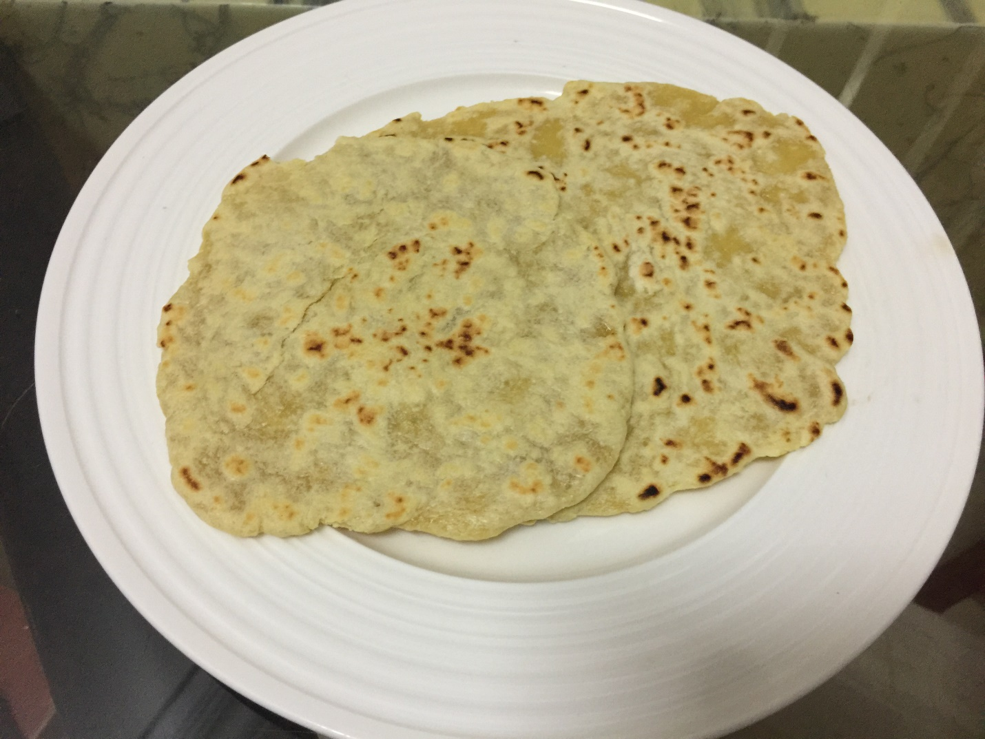

1. Western Cruisine

# **Original Chicken Milanese**

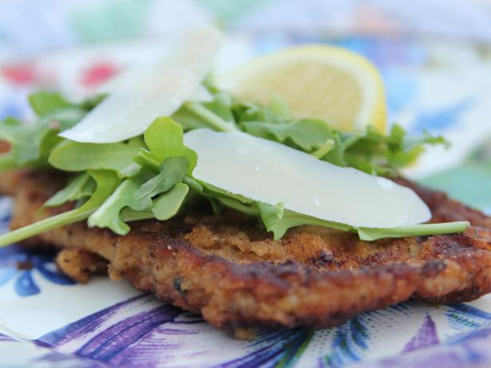

### **Ingredients**

* 2 boneless, skinless chicken breasts
* 1/4 cup whole milk
* 3 large eggs
* 1/2 cup all-purpose flour
* Kosher salt and freshly ground black pepper
  + - * cup seasoned breadcrumbs
      * tablespoons butter
      * tablespoons olive oil
* Arugula, for serving
* Balsamic vinegar, for drizzling
* 1/2 cup fresh Parmesan shavings

lemon, cut into wedges

### **Directions**

Place your palm flat against the top of each chicken breast and carefully slice each piece in half horizontally; you'll be left with 4 thinner chicken breast pieces. Place each chicken cutlet between 2 sheets of waxed paper and use the smooth side of a mallet (or a rolling pin) to pound them until they're very thin. If you think they're thin enough -- pound 'em a few more times! The thinner the better.

In a dish, whisk together the milk and eggs. Place the flour in another dish and mix in some salt and pepper. Place the breadcrumbs in a third dish. Set the 3 dishes aside for a sec.

Salt and pepper both sides of the chicken pieces, then dredge them 1 at a time in the flour, then quickly dunk both sides in the egg mixture and then coat both sides in the breadcrumbs. Lay each piece on a plate until you're ready to cook them.

Heat 1 tablespoon butter and 1 tablespoon olive oil in a skillet over medium-low heat. When it's melted and hot, add 2 pieces of the breaded chicken and cook, flipping once, until the breading is golden brown and the chicken is cooked, 2 to 3 minutes per side; transfer the chicken to a clean plate. Add the other tablespoon of butter and oil to the skillet and cook the other 2 pieces of chicken.

To serve, place 1 piece of cooked chicken on each plate. Top generously with arugula. Sprinkle with a little kosher salt, drizzle with balsamic vinegar and sprinkle on some Parmesan shavings. Serve with a lemon wedge on the side.

Serve with lemon wedges.

**Own recipe**

**Milanese**

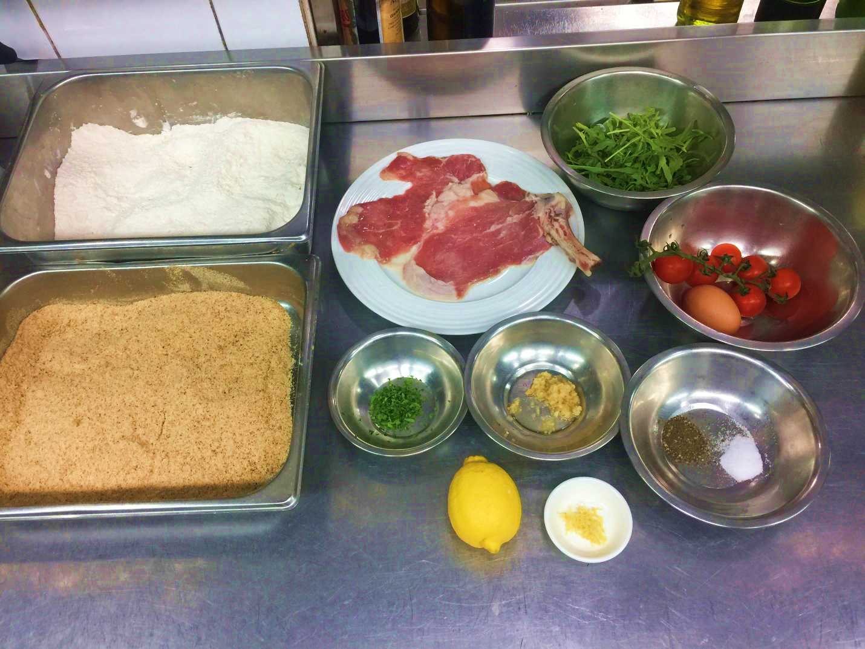

### **Ingredients**

### 1 thinly sliced veal

### ½ tbsp chopped garlic

### ½ tbsp salt

### ½ tbsp pepper

### a pick chopped herbs Italian parsley

### a pick lemon zest

### 1 egg

### Flour

### seasoned bread crumbs

### 1 hand arugula

### 6 pcs tomato cherry

1 lemon

### **Method**

1. Take a shallow dish, put in chopped garlic, salt, pepper, chopped herbs Italian parsley and beat egg and then mix together.
2. Take thinly sliced veal put in the flour and make sure both sides are stained with flour.
3. Finish the flour, then put in the shallow dish is already mix with every things, also need to make sure both sides are stained.
   1. Then take the veal both sides are stained the seasoned bread crumbs.
   2. Take a big wok put the oil and boil the oil.
   3. Oil already boiled put veal inside and fried.
   4. When veal still fried, chopped the arugula and cut the tomato cherry and lemon cut into wedges.
   5. Then take a bowl put in the arugula and tomato cherry and squeeze some lemon juice inside the mix.
   6. The veal fried until golden colour and crispy, take up the veal put the oil absorbing paper.
   7. To serve, cooked veal put a big plate, then arugula and tomato cherry already mix with the lemon juice put on the veal. Serve with a lemon wedge on the side.

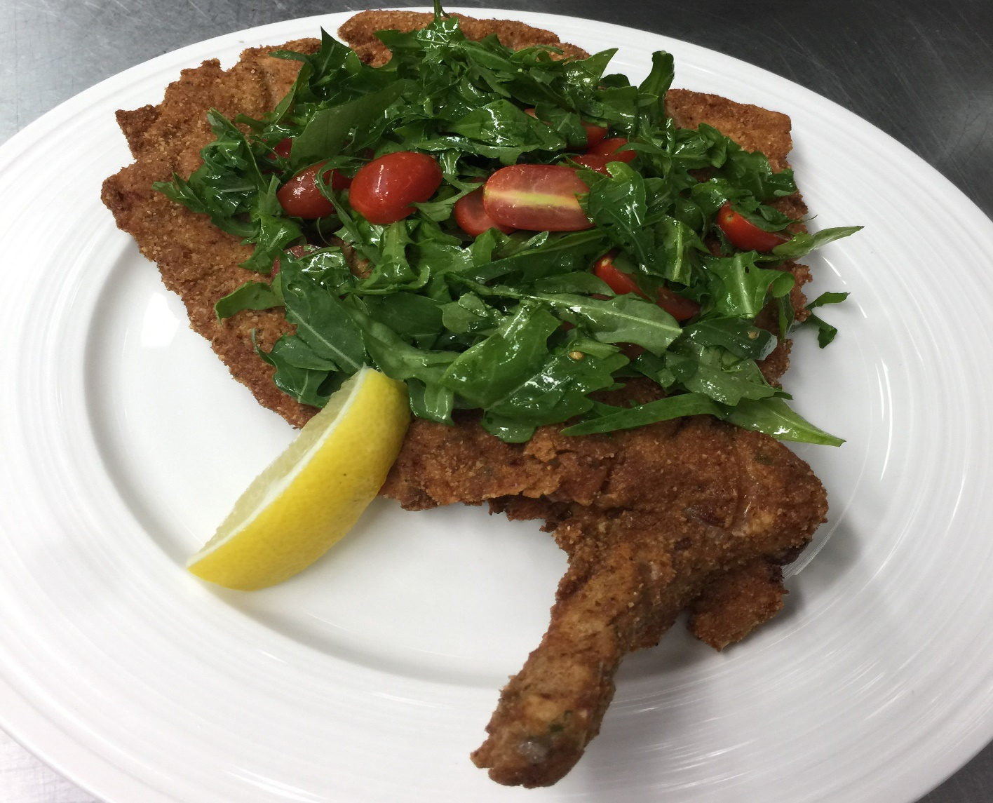

**Conclusion**

From this assignment I have learned that every country have different type of cuisine, because latitude, climate, landforms, oceans, cultures and religions are all different from each other. Because of this, every country’s lifestyle are different and they need to make sure to adapt to their lives by producing their own food, and for these reasons they have own cuisine.

Why Malaysia have the international cuisine? Because some Malaysia people like other countries food and taste very nice, but Malaysia don’t have this type of food and also too far from Malaysia. So they buy the recipe or franchise to Malaysia be the business and sharing to the other Malaysia people to know about this type of food.

**References**

By Unknown Author, Unknown Date, Online Source, How To Cook Yang Chow Fried Rice?. Retrieve from <http://ekusinero.com/yang-chow-fried-rice/>

By [Manju Malhi](http://www.bbc.co.uk/food/chefs/manju_malhi), Unknown Date, Online Source, Chapatis. Retrieve from <http://www.bbc.co.uk/food/recipes/chapatis_77146>

# By [Ree Drummond](http://www.foodnetwork.com/profiles/talent/ree-drummond), Unknown Date, Online Source, Chicken Milanese

. Retrieve from http://www.foodnetwork.com/recipes/ree-drummond/chicken-milanese-3092753